Haruka Kido

EE456: Digital Image Processing

Assignment 3

1. Filters applied to “lena_gray.jpg” image in the **frequency domain**:
2. 15x15 Average filter:

* Source code:

* Original image and its FFT transform
* Filter and its FFT transform
* Filtered image in frequency domain
* Filtered image in spatial domain

Original image

FFT transform of original image

15x15 averaging filter

FFT transform of filter

Filtered image

(in frequency domain)

Filtered image

(in spatial domain)

1. 15x15 Gaussian filter:

* Source code:

* Original image and its FFT transform
* Filter and its FFT transform
* Filtered image in frequency domain
* Filtered image in spatial domain

Original image

FFT transform of original image

15x15 Gaussian filter

FFT transform of filter

Filtered image

(in frequency domain)

Filtered image

(in spatial domain)

1. Any Sharpening filter:

* Source code:

* Original image and its FFT transform
* Filter and its FFT transform
* Filtered image in frequency domain
* Filtered image in spatial domain

Original image

FFT transform of original image

Sharpening filter

FFT transform of filter

Filtered image

(in frequency domain)

Filtered image

(in spatial domain)

1. Procedure in MATLAB to reduce the periodic noise on the background of “periodicNoiseCar.png” image:

* Source code:

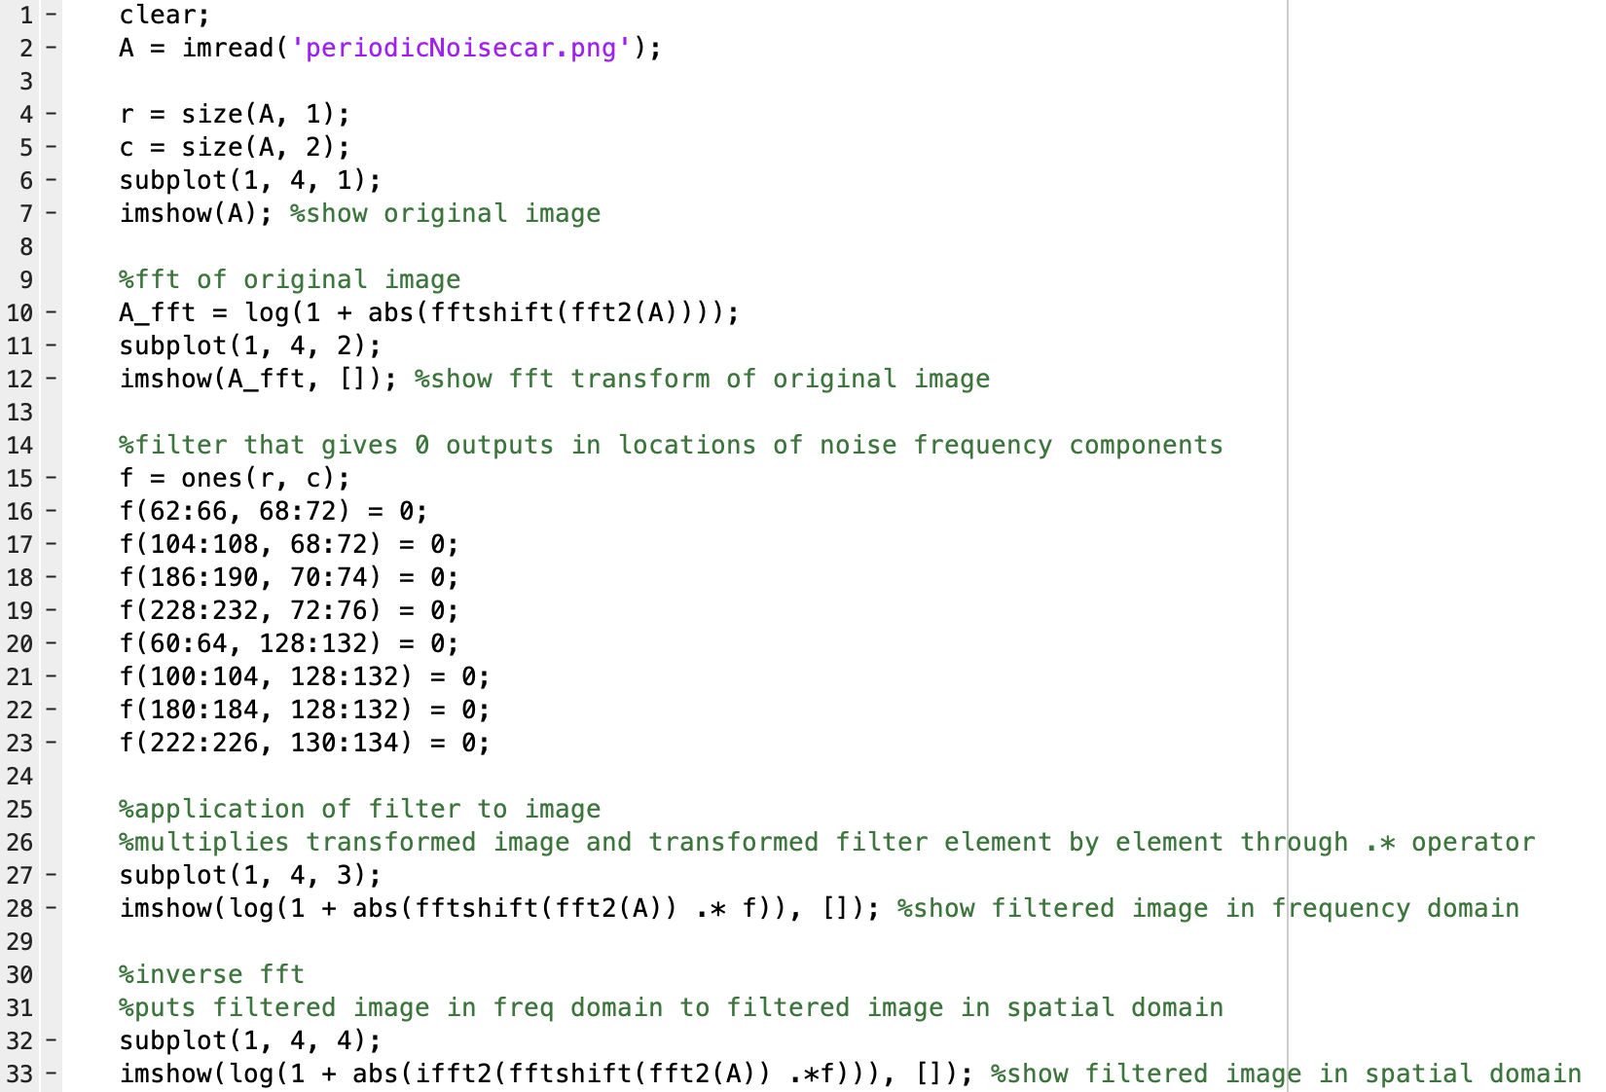

* Original image and its FFT transform
* Filtered image in frequency domain
* Filtered image in spatial domain

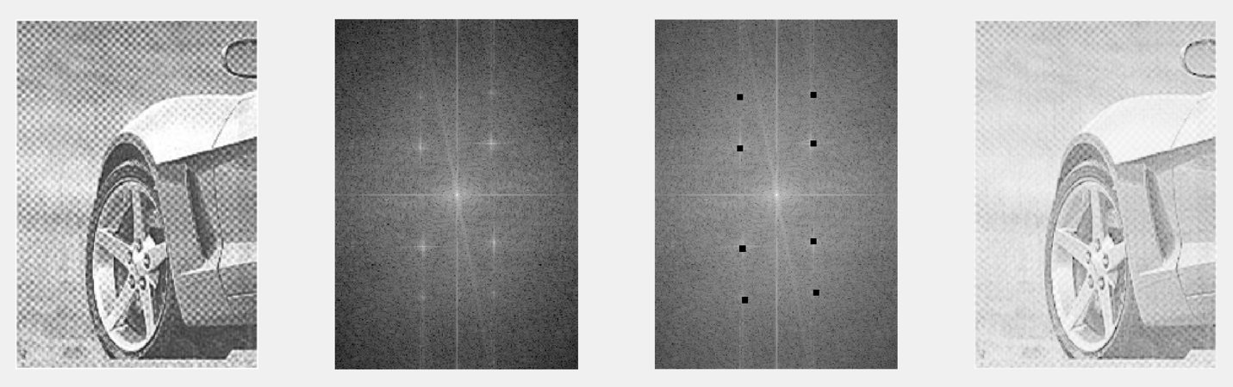

Original image

FFT transform of original image

Filtered image

(in frequency domain)

Filtered image

(in spatial domain)